
A 10
SET NO : 2

Sreenidhi Institute of Science & Technology
(An Autonomous Institution)
Code No: 101ME02

B. TECH. I – Year II – Semester Examinations, July/Aug, 2011 (Regular - AN)
ENGINEERING DRAWING - II (ME)

Time: 3 Hours Max. Marks : 70

Note : No additional answer sheets will be provided.

Part-A (Objective Type)
Max.Marks:20

Answer all QUESTIONS.

1. Write about various elements of perspective projection.

2. Write the classification of perspective projections.

3. Differentiate between isometric projection and isometric drawing.

4. List various drawing commands in AUTOCAD.

5. What are the various modelling techniques in AUTOCAD?

6. Give steps adopted in drawing intersection of solids using cutting plane method.

7. List out the applications of intersection of surfaces.

8. Define the term "Orthographic Projection".

9. Draw the isometric view of cube of 40mm side.

10. Draw the isometric view of pentagonal plane of side 20mm.

Part – B
Max. Marks: 50

ANSWER ANY FIVE QUESTIONS.
EACH QUESTION CARRIES 10 MARKS.

1. A pentagonal pyramid of side of base 25 mm and height 50 mm rests with an edge of the base, touching the P.P. The station point is on the central line passing through the apex and 80mm from P.P and 65 above the ground. Draw the perspective view of the solid.

2. Using drawing entity - LINE, give procedure for constructing
i) square of 20mm side
ii) triangle of 30 mm altitude and
iii) hexagon of side 20mm.

3. Two square prisms are intersection with base sides 30mm and 50 mm. The axes are at 90⁰ and 5 mm apart. Take the height as 100mm for both. Draw the projections with line of intersection.

-- : 2 : --

4. A vertical cone, diameter of base 75mm and axis 10mm long, is completely penetrated by a cylinder of 45mm diameter the axis of the cylinder is parallel to the H.P. and the V.P. and intersects the axis of the cone at a point 28 mm above the base. Draw the projections of the solids showing curves of intersection.

5. Draw the isometric view of a Pentagonal Pyramid, with side of base 25 and axis 60 long, when
i) The pyramid is resting on its base on HP
ii) The pyramid is resting on its base on VP.

6. Draw the isometric view of a sphere of 20mm diameter which rest centrally on a hemisphere of 40mm diameter, which is placed centrally on square block of 50mm side and 20mm thick.

7. From the orthographic view shown in figure below, draw isometric view of the object.
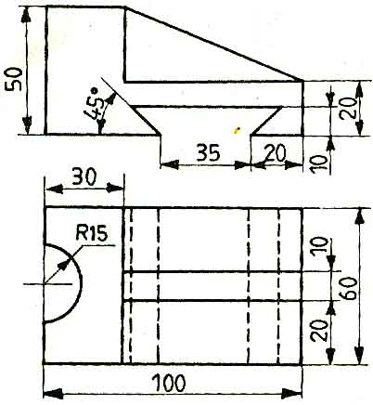

8. The domestic view of an object is shown in figure below, draw its F - V, T.V. and right side view.
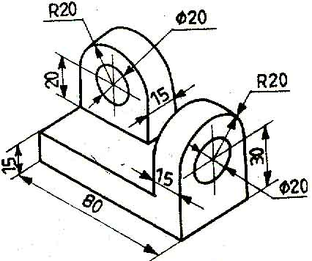

-- 00 -- 00 --

